

BULLET HELL

A PROJECT PROPOSAL

Presented to

The Faculty of College of Computer Science and Information Science

Malayan Colleges Mindanao

Davao City

by

Golosinda, Kenneth Von C.

Lauren, Nathalie

Tague, Rhine

Denie P. Forton-Paniza

Instructor

**TABLE OF CONTENTS**

Page

Title Page i

**Part I. Introduction**

Mechanics of the Game 3

Game Controls 4

**Part II. Algorithm and Flowchart**

Algorithm of the Game 2

Flowchart 3

**Part III. Interfaces** 6

**Chapter IV. Video Demonstration**  10

**Part I. Introduction**

Bullet Hell is a shoot'em up in which enemy bullets frequently almost entirely fill the entire screen. A game in which the protagonist combats a large number of enemies by shooting at them while dodging their fire. The controlling player must rely primarily on reaction times to succeed. This type of game is often referred to as "curtain shooting," "manic shooters" or "maniac shooters." In the mid-1990s, this type of game emerged and is an offshoot of scrolling shooters. The origins of the genre can be traced back to Spacewar! Created in 1962, it was one of the first computer games. The shoot'em up genre was later generated by the hit arcade game Space Invaders, which in 1978 popularized and set the general framework for the genre, and then arcade hits such as Asteroids and Galaxian in 1979 established the genre further. Throughout the 1980s and early 1990s, shoot'em ups were common. Shoot'em ups became a niche genre in the mid-1990s based on design conventions developed in the 1980s, and catered increasingly to specialist enthusiasts, particularly in Japan.

**Mechanics**

------------

- You only take damage if something hits your red square, but a single hit kills you

- Defeat enemies to gain valor

- Whenever an enemy leaves the area, you lose valor

- A more difficult enemy will appear after you survive for a while

- There's a different outcome at the end if you don't kill any enemies, but that's pretty much impossible

**Controls**

--------

Z - fire/confirm

Shift - slow mode

Arrow keys - move

**Part II. Algorithm and Flowchart**

In this section we discuss the algorithm used for our blackjack game and the flowchart.

**Algorithm:**

1. Set Greatest Valor to 0.
2. Display Main Menu Interface.
3. Press “Z” to start game.
4. Display game terrain.
5. Set player’s position.
6. If player got hit by an enemy projectile, refer to **13**. If not, continue.
7. If player pressed an arrow key, the player sprite will move to which arrow direction.
8. If player hold and pressed the “SHIFT” key, decrease player movement. If not, continue
9. If player pressed the “Z” key, then player will shoot a projectile. If not, go back to **5.**
10. If player projectile hit an enemy position, destroy enemy sprite, and increase valor points. If not go back to **5.**
11. If previous greatest valor < new valor, save the new score. If not, retain previous score.
12. If user press the close button, continue. If not go back to **2**.
13. Game Ends

**Flowchart:**

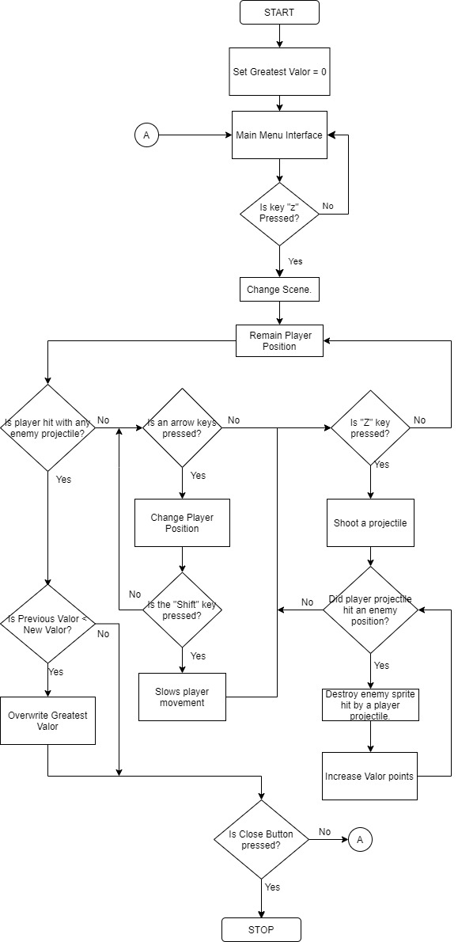

**Figure 1. Flowchart of the game**

**Part III. Interface**

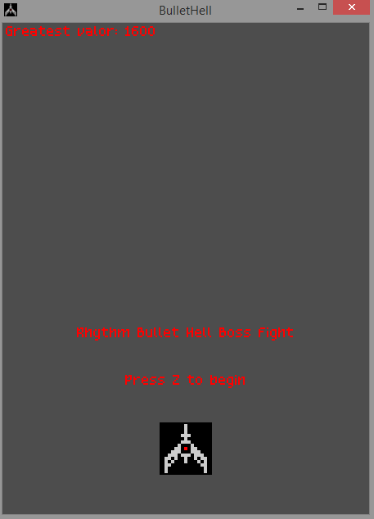

**Figure 2.0 Main menu interface**

This is the Main Menu of Bullet hell, to begin the game the user must press the “Z” key. The valor is the score of the game. Highest valor points is displayed at the top left of the main menu.

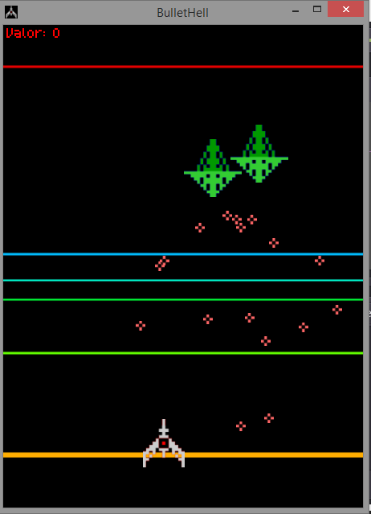

**Figure 2.1 The Gameplay**

The game is an endless run, the longer the player plays the game the more enemy will appear.

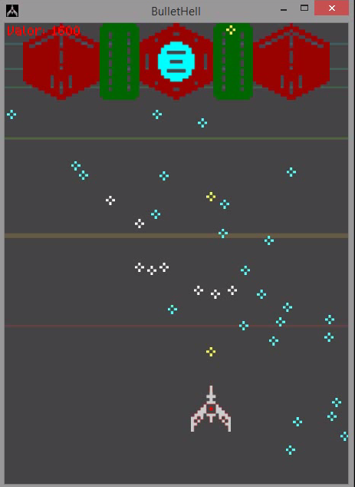

**Figure 2.2 The First Boss**

There is only one boss in the game, once defeated, enemy spaceship will arrive again, and the boss will return once again after a few minutes.

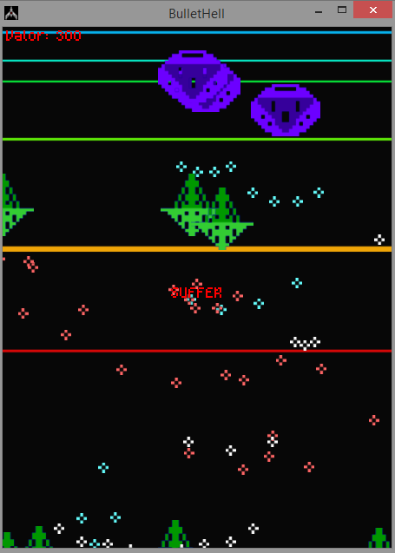

**Figure 2.3 Game Over**

The game will end only if the player was hit by an enemy projectile. It will return to the back to the main menu interface, if the current score was greater than the previous score the greatest valor will be updated.

**Chapter IV. Video Demonstration**

https://malayancollegesmindanaoo365.sharepoint.com/:v:/s/CS110-2SY20-211S/ET-9RzR25fdCjZ57LfyRK7oBDs6KWM6CNZff2RBYHAhKQg?e=Fg5yr5